Choose Chicago Mock June Social Calendar
By Anna Kuell
PRAD 256
19 May 2024

Date/  Time | Caption | Image | LI | FB | IG | X
June 1  Saturday  10:00 AM | Hello June! Farmers market season is officially here, Chicago 😚 We present to you the full list of CHI farmers markets🌈🍓#chicago #choosechicago #farmersmarket | 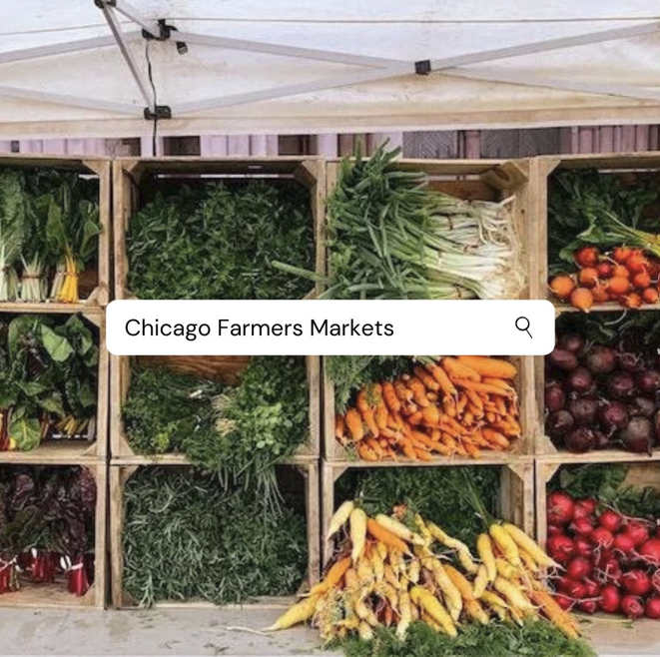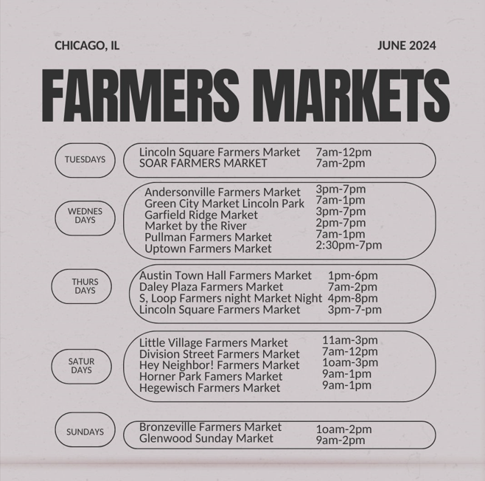 |  | ✔ | ✔
June 7  Friday  2:00 PM | 🚀 Open Call for Vendors: Bean Bash 2024! 🚀  We are thrilled to announce the Bean Bash, celebrating the reopening of Chicago’s iconic Cloud Gate at Millennium Park on Thursday, August 1, 2024. This day-long celebration will feature the official unveiling of the improved Cloud Gate, live music, and a vibrant selection of food trucks and local vendors.  With an expected attendance of approximately 5,000 attendees, this is a fantastic opportunity for vendors to showcase their products and services to a large and diverse audience. We are looking for passionate and high-quality vendors to join us in making this event unforgettable.  Event Details:  🗓️ Date: August 1, 2024  🕒 Time: 11:00 AM to 7:00 PM  📍 Location: Millennium Park, 201 E. Randolph St., Chicago, IL 60601  Vendor Requirements:  - Must offer high-quality products or services suitable for a large public event  - Able to operate for the duration of the event (11:00 AM - 7:00 PM)  - Compliance with all local regulations and event guidelines  Interested vendors are invited to apply by contacting Anna Kuell at akuell@depaul.edu or calling (207) 650-6309.  Don't miss this chance to be part of a landmark celebration in Chicago! We look forward to showcasing the best that our local community has to offer.  #BeanBash2024 #ChicagoEvents #VendorCall #CloudGateReopening #LocalVendors #FoodTrucks #LiveMusic |  | ✔
June 14  Friday  Noon | Planning a trip? Do it right, Discover the hidden gems of Chicago with our comprehensive guide! From secret speakeasies to hidden parks, explore the city like never before. 🕵️‍♂️ #HiddenChicago #ExploreChicago #CitySecrets | 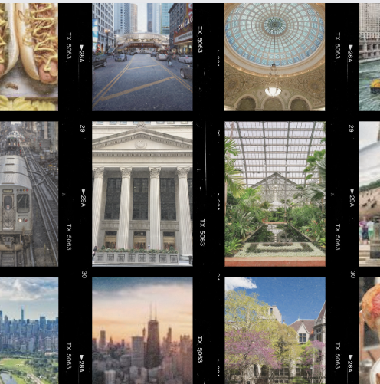 |  |  | ✔ | ✔
June 20  Thursday  10:00AM | Planning a corporate retreat? A family reunion? A wedding? Chicago offers world-class venues and unforgettable group experiences. Discover why your next event should be here. #CorporateRetreat #Choose Chicago #weddingVenue #ChicagoBusiness | N/A |  | ✔ |  | ✔
June 28  Friday  2:30PM | Colors of summer in Chi 😚 Thank you JUNE! Thank you CHICAGO! What a beautiful month, thank you to everyone who used our services while exploring the city this month. Share your favorite Chicago moments from this month by tagging us in your post for a chance to win some free Choose Chicago swag😎#choosechicago #giveaway | 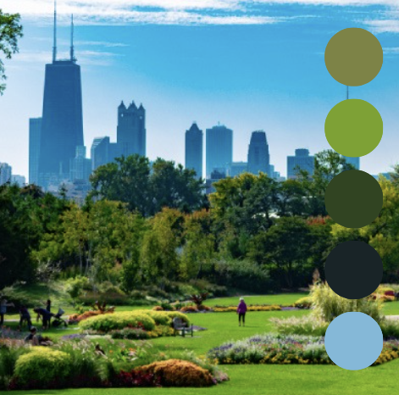 |  | ✔ | ✔

KEY
LI → LinkedIn
FB → Facebook
IG → Instagram
X → Twitter

