Anna M. Kuell
20 February 2024
Dr. Nur Uysal
PRAD 255: Social Media Analysis
OLIPOP
Introduction
In 2018, Ben Goodwin and David Lester launched OLIPOP with a vision of selling tonics that were both tasty and healthy, unlike a typical soft drink. OLIPOP received its first big break in 2018 when it began appearing on shelves at Erewhon, a ritzy, exclusive grocery store in California known for being a hotspot for celebrities. In the years since, OLIPOP has gained major traction and has expanded to selling in several other select grocery stores and markets (Whole Foods, Target, Publix, etc.) (Pashman et al., 2024). OLIPOP’s main appeal is its relative health benefits compared to other sodas. Their website boasts that their sodas contain 2-5g sugar, 9g plant fiber, botanicals, and prebiotics while still tasting “like the soda you grew up sipping” (Olipop Digestive Health). OLIPOP is not the only brand to take on this market though. Competing health-conscious sodas like Poppi and Culture Pop occupy the same shelves and have similar look, taste, and brand feel.
OLIPOP’s brand objective is, "Life is too short not to enjoy it, and too long to spoil it. We can have our sweet cravings without sacrificing our health. Soda is a shortcut with no long term benefits. OLIPOP is an off ramp to a healthy and delicious experience” (The olipop story). In this social media analysis for PRAD 255 (Public Relations), I will be examining how OLIPOP uses social media strategy to promote this vision. And, furthermore, how they target their content towards key consumers (health-conscious Gen-Z and Millennials), attempt to individualize their product amongst a growing market of niche soda brands, and increase brand awareness.
OLIPOP has a presence on all major social media platforms (Instagram, Facebook, X, TikTok, LinkedIn, TikTok, etc.) For this project, I am going to focus on their Instagram and TikTok accounts. I have chosen these platforms because they are OLIPOP’s most active and have the largest audience. OLIPOP has 264K followers on Instagram and 387K on TikTok. The brand consistently uses a clean and bright aesthetic, reminiscent of classic vintage cola cans but adds a modern pop of color. They lean into nostalgia and sentimentality, utilizing retro fonts and minimalistic designs. Observation of OLIPOP’s social media pages show that they partake in both one-way and two-way communication. Furthermore, OLIPOP utilizes influencer marketing and product placement on both platforms. The following sections will detail OLIPOP’s communication strategies as seen on their social media accounts.
Social Media Level-One Performance Metrics and Analytics
During the approximately one-month period (January 8th through February 11th, 2024) during which I observed OLIPOP’s Instagram and TikTok pages, the brand experienced some slight growth in engagement and follower count on both social media sites. Primarily, their content during this period made use of pop culture events, holidays, and viral social media trends. For example, on both their TikTok and Instagram OLIPOP posted content multiple times about the Superbowl and Valentines Day as well as spoofs on viral internet moments like Spotify Wrapped.
- Instagram (@drinkoilpop)
During the observation period, OLIPOP posted to their Instagram feed a total of 16 times, seven of which were short form videos, five carousels, and four single image posts. They averaged one post every two days. The account saw a 4.76% increase in followers, up approximately 12,000 followers since the start of January. Their engagement rate (total number of likes and comments divided by total number of followers) for this period was 3.27%. The most popular post (example A) was made on January 25th; it received 15.4k likes and 10.9k comments. The post was made in reference to their recent partnership with Costco, the caption detailed a giveaway opportunity with the potential to win their “coveted Costco 8-pack.” The post that performed the worst (example B) was made on February 9th; it received only 630 likes and 19 comments. The post was an image of model, micro-influencer, and OLIPOP Partner (@niyiaedun) holding a can of Cream Soda flavored OLIPOP. The accounts most frequently used hashtags were: #olipop, #newkindofsoda, #prebioticsoda, #guthealth, and #mocktail. In addition to traditional feed posts, the OLIPOP Instagram account regularly makes use of their story, often posting upwards of ten stories a day. Typically, these stories were re-posts of UGC and costumer testimonials.
Example A: Example B:
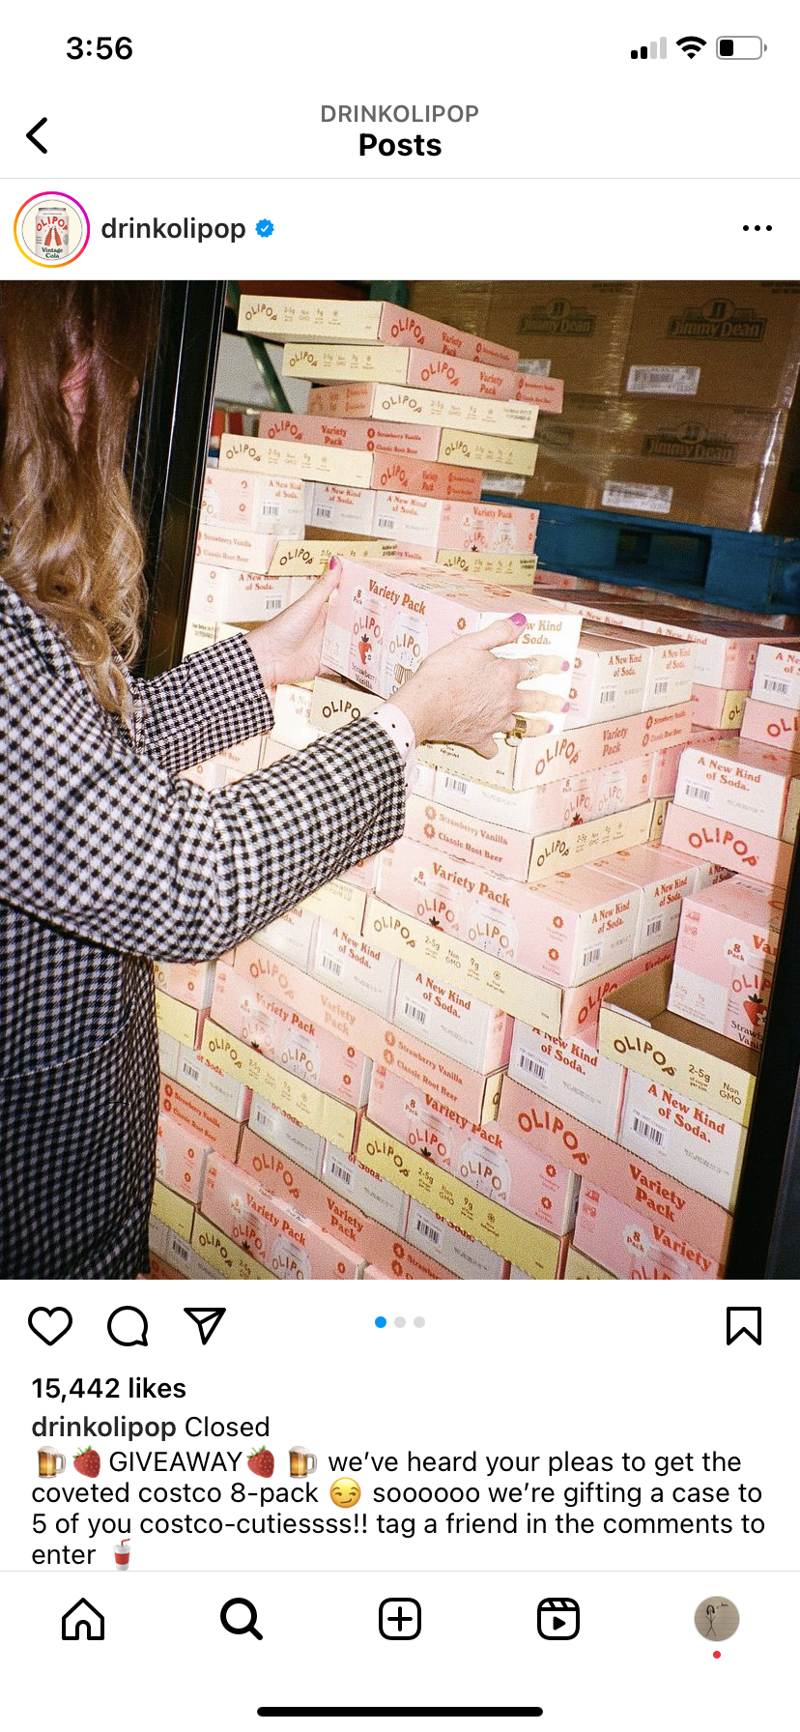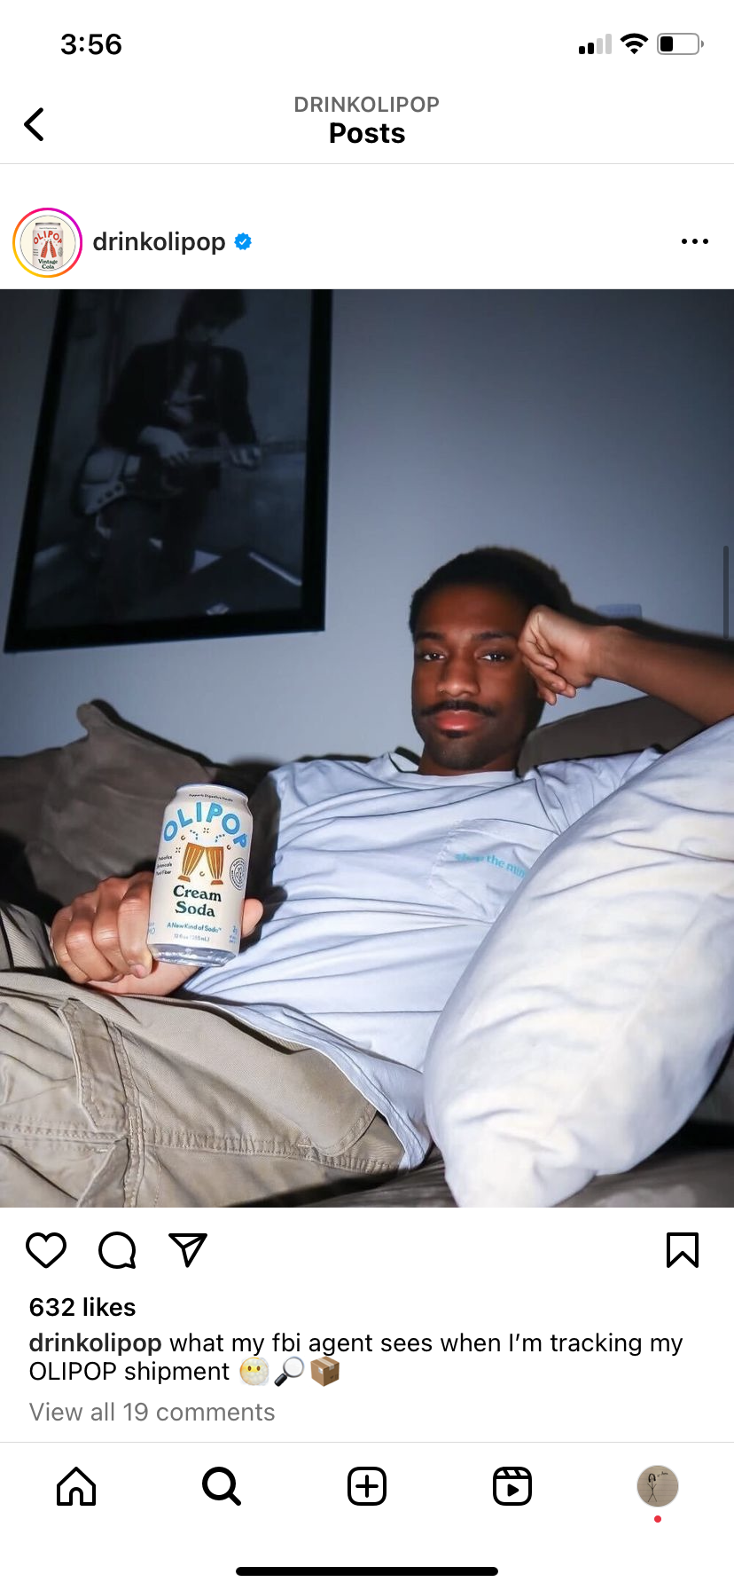
- TikTok (@drinkolipop)
On TikTok, OLIPOP posted to their feed 22 times, averaging one video every 1.5 days. Their account was up 51,000 followers with a 15.17% increase since the start of the observation period. Their average view rate (number of videos divided number of followers) was 7.82%. The account’s most popular TikTok (Example C) during this period was made on January 15th and received 1.1 million views, 6.8k likes, 127 comments, and 384 shares. The video is a tutorial on how to make an adrenal mocktail using OLIPOP’s Orange Squeeze flavor, coconut water, and sea salt. Their worst performing video (Example D) is strikingly similar; it is also a tutorial, this time showing how to make a dolce spritz mocktail using orange juice, cranberry juice, and the same Orange Squeeze OLIPOP from the other video. Whereas the other video (Example C) received upwards of a million impressions, this video only received 7.7k views, 283 likes, 8 comments, and three shares. OLIPOP’s TikTok used the same hashtags as its Instagram. On TikTok, they actively repost videos made by both influencers and everyday TikTok users that reference their product (see example I in Strategies and Tactics #3).

Example C: Example D:
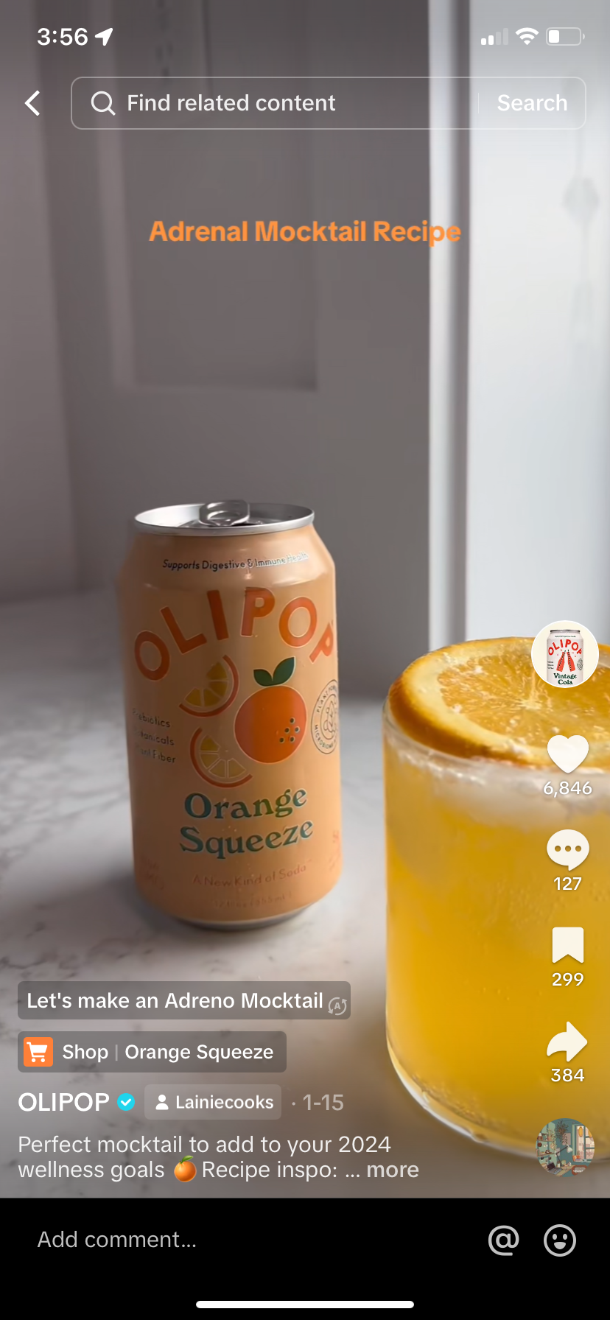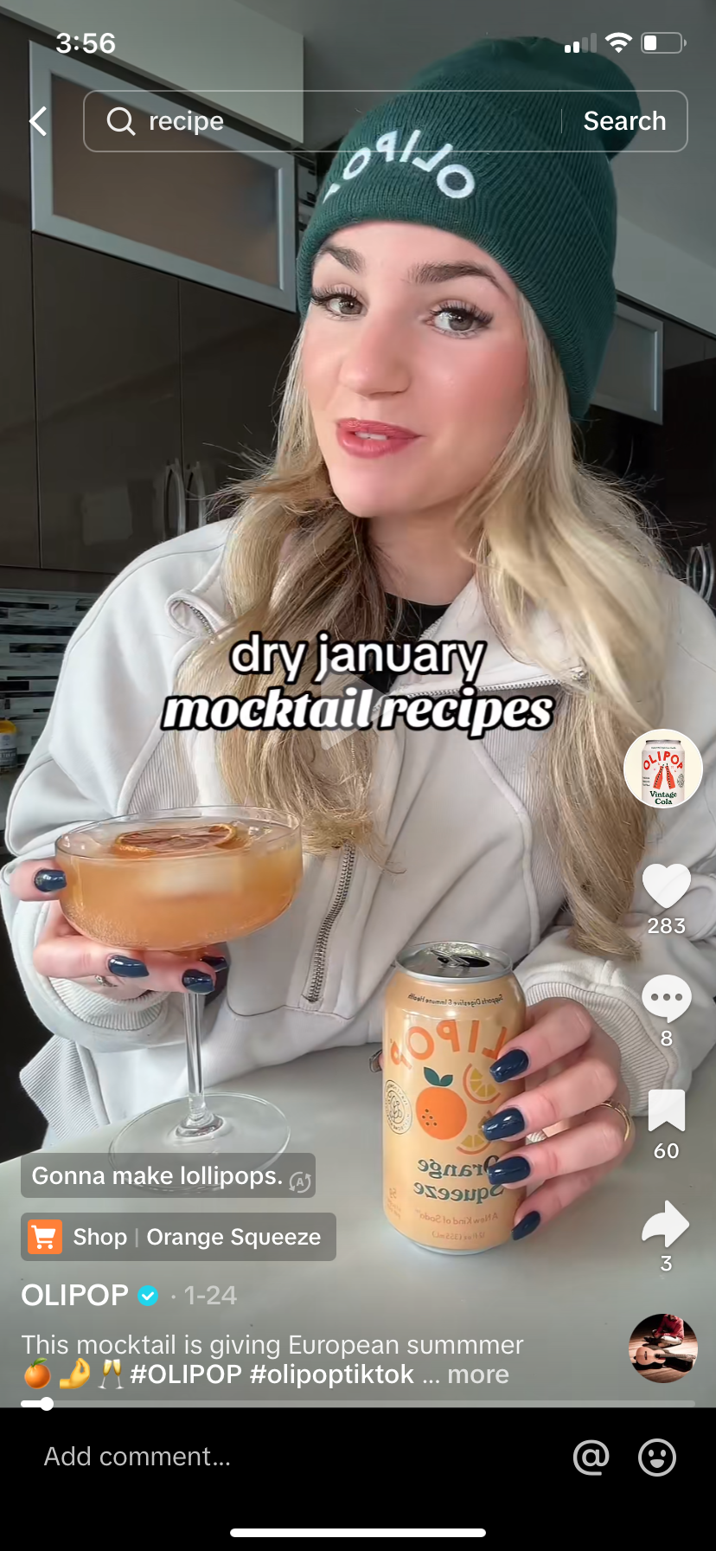
- Distinction Between Platforms
OLIPOP utilizes the two platforms, Instagram and TikTok, in two distinct ways and thus engagement differs. While their TikTok account has amassed more followers than their Instagram (125.1K more, to be exact), the latter drums up more engagement regularly than the former. On Instagram, the brand regularly sponsors and promotes giveaways (three during the observation period) with the stipulation of commenting and/or following to be entered. This style of post draws significant attention and engagement that is not replicated with the same success on their TikTok.
Strategies and Tactics #1: One-Way Communication and Publicity
One of the more commonly used communication strategies exercised on OLIPOP’s social media is one-way communication. On Instagram, OLIPOP routinely posts high quality images of their products with information on the health benefits, ingredients, and where they can be purchased. The captions do not ask for feedback or encourage interaction. A post (Example D) made-on February 2nd with the caption, “POV you find out OLIPOP is now being sold at Aldi (CA and TX) so you roll up with your bestie to grab some before the weekend” with an accompanying image of two young people standing outside an ALDI holding cans of OLIPOP toward the camera demonstrates this one-way style of communication. Despite not directly calling for engagement, the post still earned over 200 comments.
On TikTok, OLIPOP employes the same one-way technique. Like in a video (Example E) made-on February 7th that that shows a young woman restocking her fridge with the OLIPOP Best Sellers Pack. The video serves as a reminder of the plethora of products and packs that OLIPOP has available. Furthermore, both channels post tutorials on how consumers can use OLIPOP to create mocktails or other beverages. In line with one-way communication, these posts are initiated by the organization and serve to inform their publics with truthful and relevant information about their products.
OLIPOP is able to commit to a consistent brand image through one-way communication. This includes showcasing their products both aesthetically and ingredient wise. OLIPOP’s target demographic is Gen-Z and Millennials who they strategically target in this one-way communication by using visually pleasing images and participating in social media trends.
Example D: Example E:
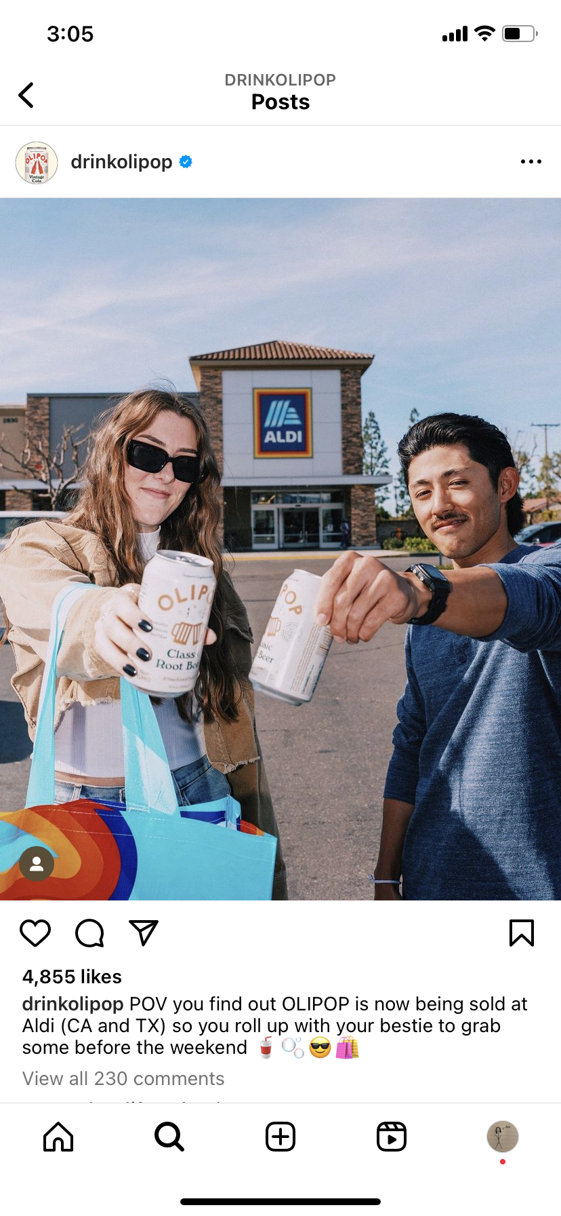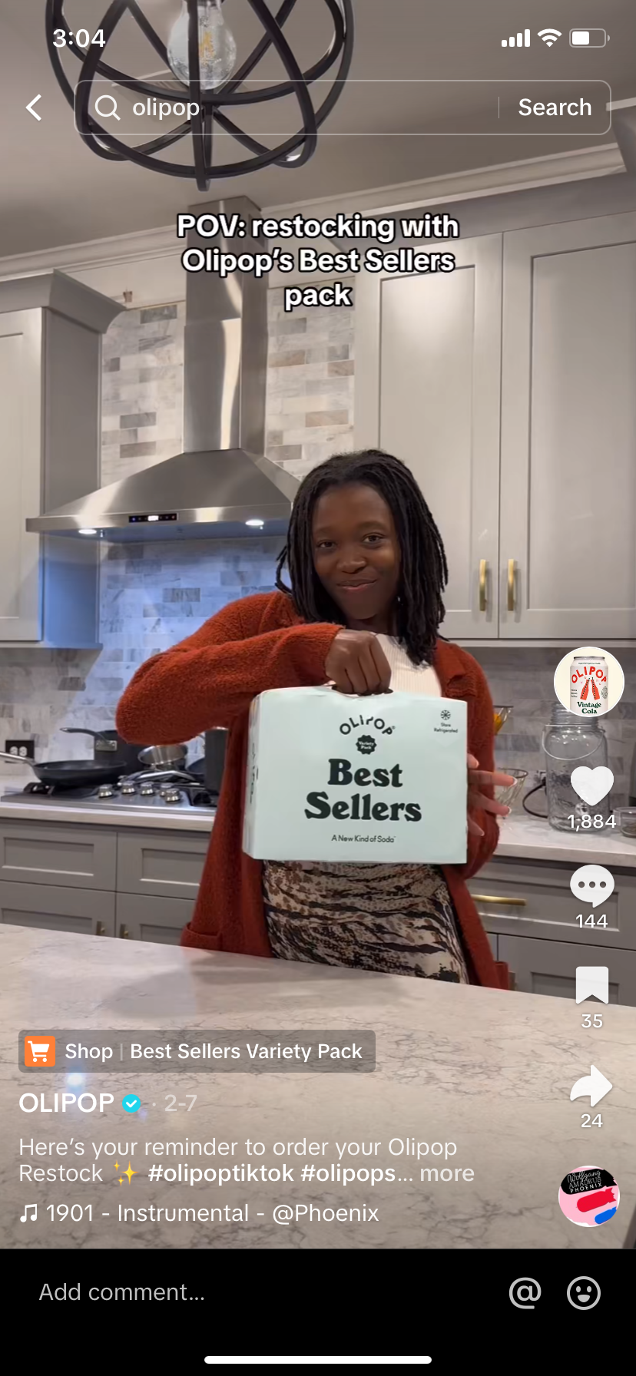
Strategies and Tactics #2: Two-Way Communication and Engagement
Two-way communication, or content that encourages interaction between an organization and their publics, is frequent on OLIPOP’s social media pages. The most prominent example, which was mentioned previously, are the giveaways they routinely host on Instagram that require engagement with the account. In the same vein, many of their posts are accompanied by captions that say things like, “tag someone you want to recreate this with" (Example F), "Tag ur boss a$$ besties who absolutely hate feelings but jadore responsibilities” (Example G) or asking followers to comment their favorite flavor or way to drink OLIPOP. This tactic of asking followers to manually tag or interact with OLIPOP’s posts works well for certain audiences but does not work for everyone. Gen-Z consumers, having grown up in the digital age, are harder to win over and search for more authentic promotion; They therefore are not as swayed by the comment and tag tactic as millennials (New Research: Gen Z Harder to Win Over by Brands, Media, and the Companies Recruiting Them 2019).
OLIPOP also finds success in two-way communication via reposting customer content, on Instagram using the story feature and on TikTok in their reposts. Use of customer testimonials and reviews lends the other benefit of third-party credibility. This is an example of the authenticity that Gen-Z consumers seek. Additionally, in the past OLIPOP has hosted user-generated content campaigns and endorses/sponsors many influencers and celebrities with hashtags like #Olipoppartner (more on this in Strategies and Tactics #3) all of which drum up engagement.
Example F:
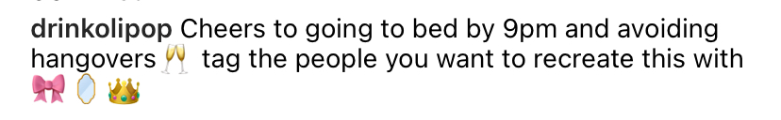
Example G:
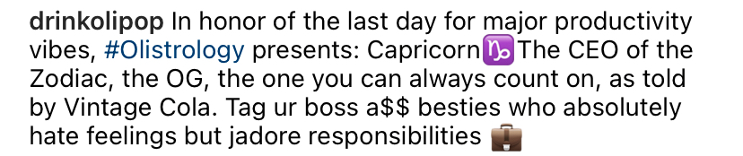
Strategies and Tactics #3: In-House Creators, Product Placement, and Trend Participation
AdAge ranked OLIPOP #5 on its 2023 Marketers of the Year list. This achievement was given in recognition of the brand's successful integration of influencer marketing and their innovative use of an in-house ad agency (Follett, 2023). OLIPOP’s TikTok is operated by a group of in-house content creators that upload nearly daily to the account. Their videos stray away from direct promotional content and sales pushes. Rather, their team publishes videos that are entertaining and often have their own take on currently trending TikTok sounds, viral memes, or cultural moments. During the observation period, for instance, OLIPOP posted a video tutorial (Example H) of how to make the trending “sleepy girl mocktail.” Major media outlets among the likes of the Today Show, Good Morning America, and the New York Post all aired segments and/or published articles about the sleepy girl mocktail. As the Today Show put it, “TikTok users claim the mix of tart cherry juice, magnesium powder and prebiotic soda is giving them the best sleep of their lives” (Steinhilber, 2024). Being a prebiotic soda, OLIPOP seized the opportunity to gain natural engagement and began posting their own tutorials, commenting on others, and using the hashtags #sleepygirlmocktail, #sleeptips, etc. This is a prime example of how the brand uses trend integration for publicity in leu of traditional advertising techniques like promotional codes or direct sales pitches.
Similarly, if you were to browse the repost section on OLIPOP’s TikTok account, there are other examples of “naturally” occurring promotions. TikTok user @maddyhollander recorded and uploaded a video (Example I) of popstar and lead actress in the new Mean Girls movie reboot, Renee Rap, at a press conference/interview in which she spotted a can of OLIPOP. Rapp says, “There’s an OLIPOP can sitting right there [...]” she gestures to the can a fan had put on the edge of the stage, “you guys are so funny...Can I actually have it? Amazing, thanks man.” Seemingly unplanned, a natural celebrity interaction with a product is an amazing opportunity to get more eyes on the brand. OLIPOP did not miss the chance to boost Rapp’s casual acknowledgment and recognition of them.
Example H: Example I:
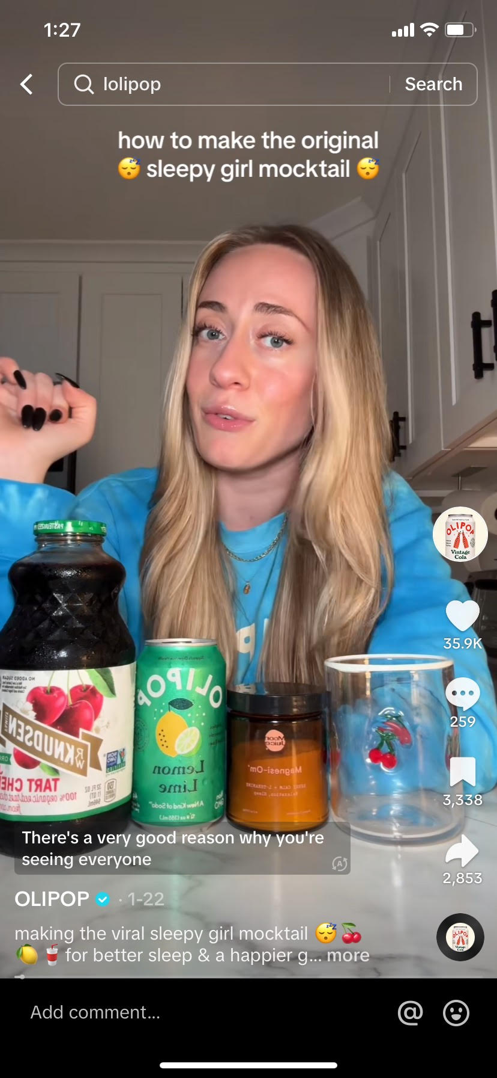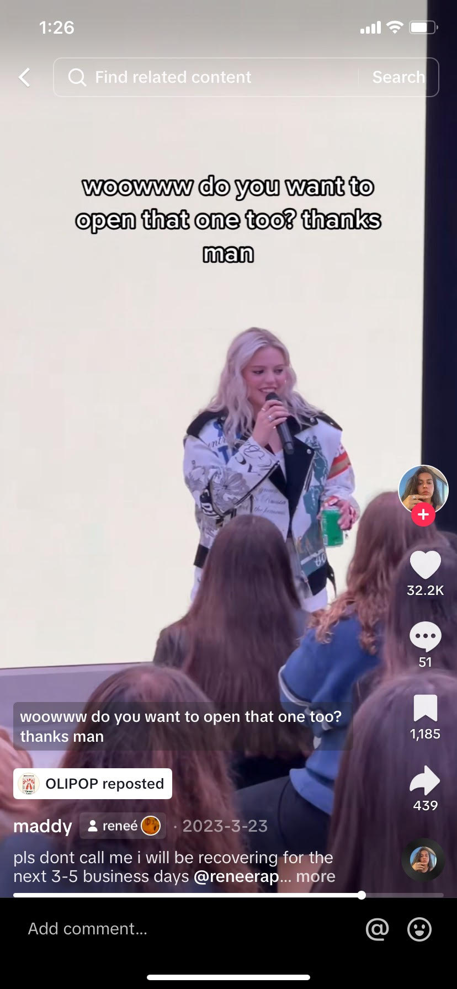
On Instagram due to the platform modality OLIPOP has less opportunities to seize natural promotional content. Therefore, they more frequently engage in pop culture moments and social media trends. For example, in response to Spotify’s new viral “daylist” feature that curates custom playlists for users, OLIPOP created a custom graphic (Example J) that mocks the style of a daylist but changed the title of the songs to things like “That Gut Feeling” and “Getting Fizzy With It.”
Example J:
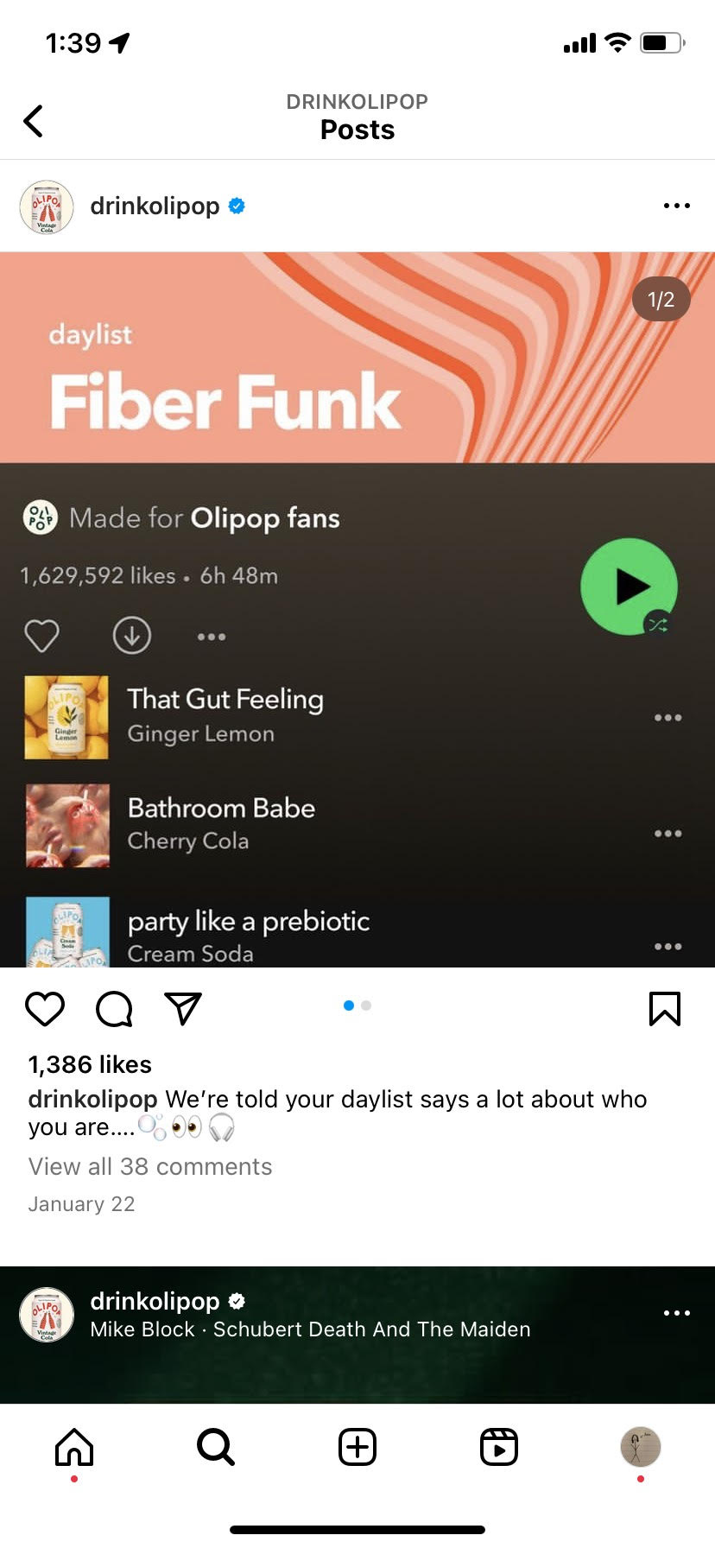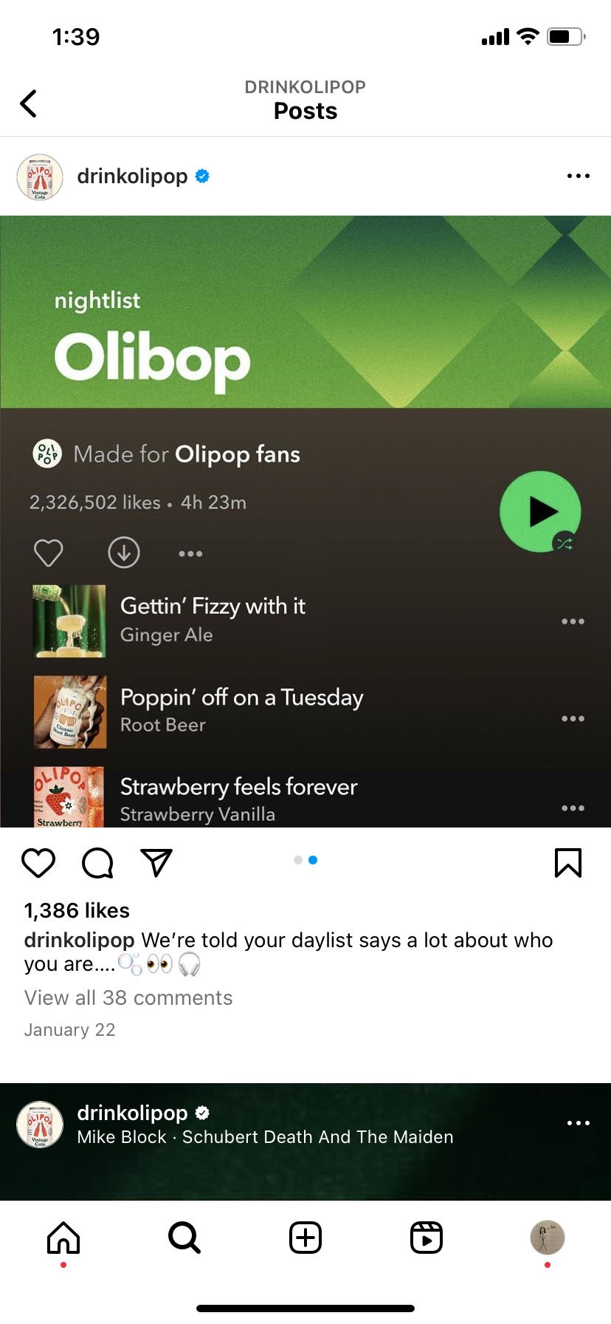
This is just one of many examples of OLIPOP incorporating their own content into viral social media trends. This style of posting encourages customers to share and interact with the posts, grows the brand audience, and has the potential to generate conversation around the brand. Furthermore, OLIPOP uses these posts as an avenue to engage with consumers and, in turn, boost brand loyalty.
Discussion and Recommendations
OLIPOP is a success story of modern advertising and social media promotion. They have been able to successfully integrate social media tactics into their publicity blueprint. They do an amazing job at maintaining a consistent brand image across all platforms, utilizing the same bright colors, youthful feel, and contemporary trends. OLIPOP is aware of its target audience and puts out content that is relevant and appealing to that consumer base.
Yet, OLIPOP has no lack of competitors. In general, there are countless soda brands but even more narrow, prebiotic and health soda brands are becoming increasingly popular. OLIPOP’s main competitor is Poppi, a brand that is conspicuously similar beyond just the name. Take, for example, OLIPOP’s and Poppi’s Instagram bios:
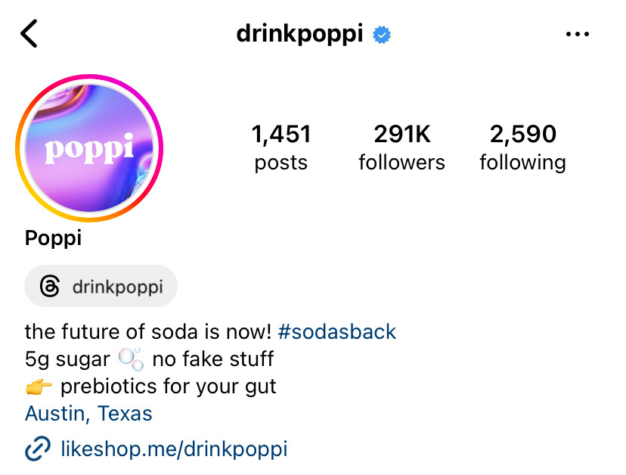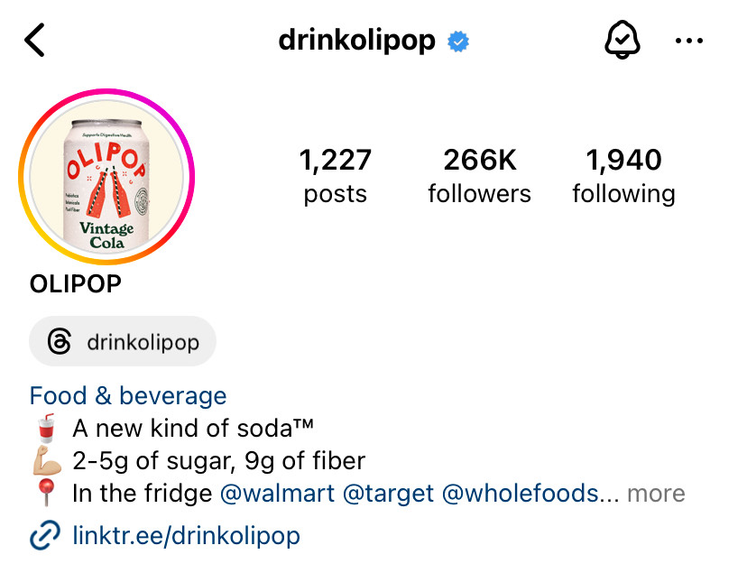
The two brands have extremely similar branding and aesthetics. The saturation of the shelves that OLIPOP occupies is a weakness that they do not remedy well enough through their social media. I would recommend that OLIPOP creates more distinct branding while maintaining some of the vintage aesthetic that is working for them currently.
A tactic I recommend OLIPOP use is character association. In the past, mascots like the Pillsbury Doughboy and Kellogg's Tony the Tiger have served as the face of their companies, creating a recognizable and friendly foreword facing character for the brand. Recently brands like Duolingo have used character association to create a cultural icon of sorts out of their mascot. OLIPOP can capitalize on this advertising method; in fact, they have already taken steps in the right direction. A Tiktok (Example K) posted-on February 15th and a Instagram post (Example L) from February 5th featured OLIPOP’s in-house creators wearing a human sized costume that look like cans of OLIPOP in various flavors. If they continue with this “mascot” and amp up the content featuring this costume, OLIPOP could further distinguish itself from competitors. For OLIPOP, animating and personifying their can as a brand mascot could be a very smart move, and one that none of their competitors have yet to do.

Example K: Example L:
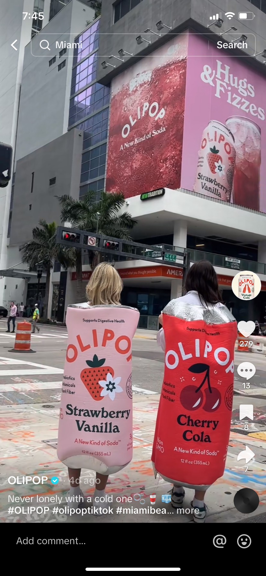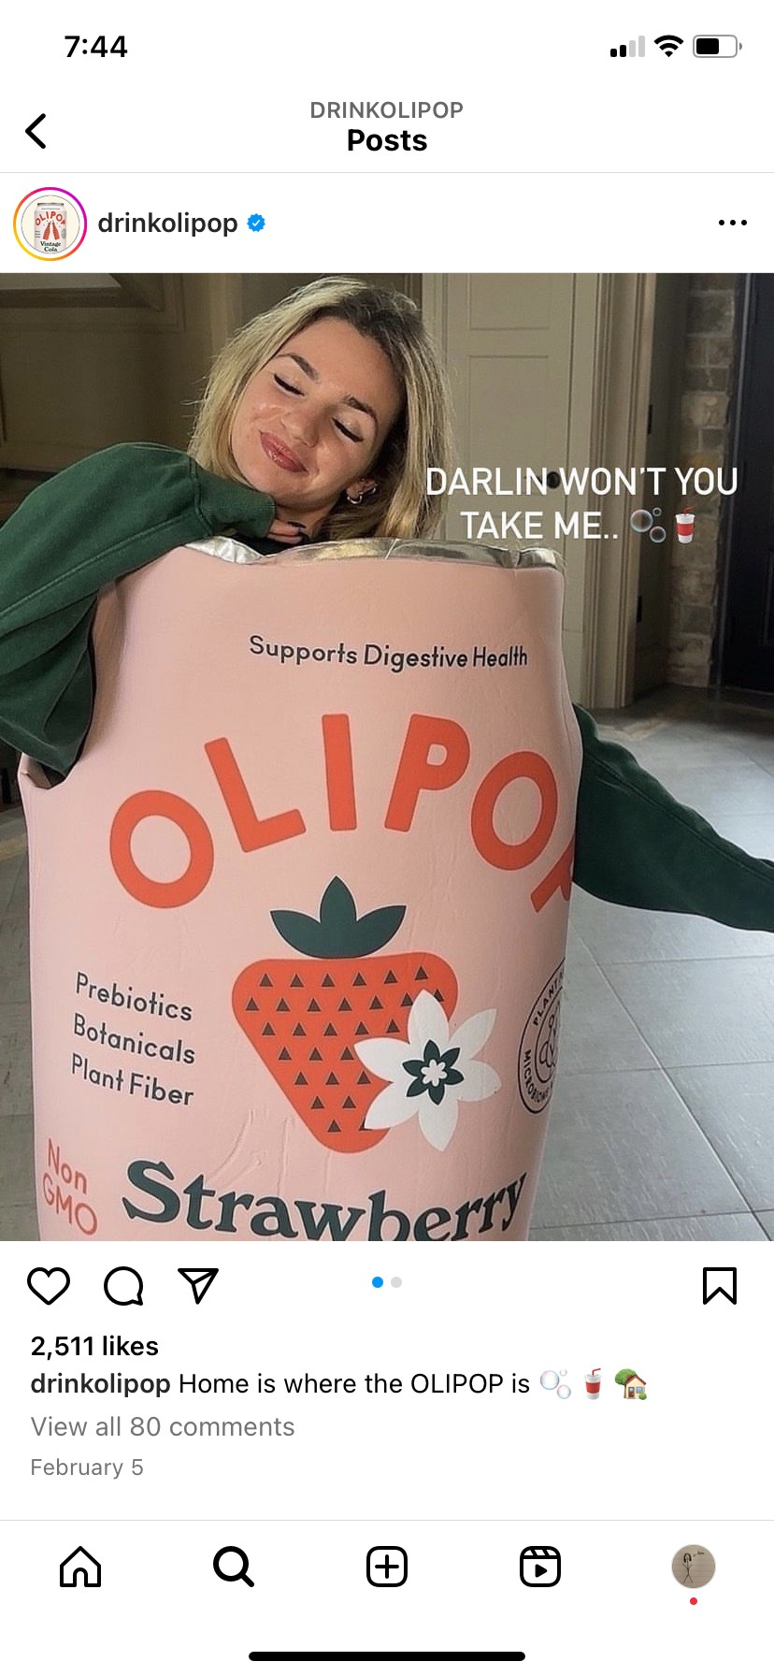
Conclusion
At only six years old, OLIPOP has made an impressive impact in the beverage industry, earning accolades and consumer popularity. This is, in part, thanks to their stellar social media presence. OLIPOP has successfully navigated the clutter of the internet and made themselves known. This is no little feat in a day and age where advertising and promotions dominate the internet floor to ceiling. The constantly evolving digital age has posed unique challenges and created new responsibilities for public relations professionals. Each new platform and emerging trend mean brands must pivot their communications strategically to effectively reach their publics. Amongst all the noise, OLIPOP has curated a brand image that is clean, cohesive, and appealing. On social media, they maintain a friendly, colorful, and bubbly personality that draws consumers in and earns their loyalty. It is essential that brands work with public relations practitioners to ensure that they are putting forth content that is relevant, truthful, and appealing. The internet is a rapidly changing space, and audiences appreciate it when a company provides clarity through thoughtfully made content. People like to be seen and heard, OLIPOP ensures this by regularly engaging with their followers. They post images and videos of young people, their key consumers, which allow their followers to see themselves in the brand. The power of listening and responding, hearing, and seeing, cannot be underestimated, especially in modern-day public relations.

References
Follett, G. (2023, January 9). How viral tiktok soda brand Olipop built its influencer marketing ... AdAge. https://adage.com/article/digital-marketing-ad-tech-news/how-viral-tiktok-soda-brand-olipop-built-its-influencer-marketing-strategy/2462031.
New Research: Gen Z Harder to Win Over by Brands, Media, and the Companies Recruiting Them. (2019, February 13). The Atlantic. Retrieved from https://www.theatlantic.com/press-releases/archive/2019/02/-original-study-from-atlantic-rethink-on-gen-z/582799/.
Olipop Digestive Health. OLIPOP. (n.d.). https://drinkolipop.com/pages/digestive-health.
Pashman, D., Wong, W., O’Hara, A., Ritchey, J., & Hirsch, P. (2024, January 25). How niche brands got into your local supermarket. The Indicator from Planet Money. broadcast, NPR.
Steinhilber, B. (2024, January 18). Can the “sleepy girl mocktail” really help you fall asleep faster? TODAY.com. https://www.today.com/health/diet-fitness/sleepy-girl-mocktail-rcna81975.
The olipop story. OLIPOP. (n.d.). https://drinkolipop.com/pages/our-story.

OLIPOP [@drinkolipop]. (2024, January 19) In honor of the last day for major productivity vibes, #Olistrology presents: Capricorn♑️The CEO of the Zodiac, the OG, the one you can always count on, as told by Vintage Cola. Tag ur boss a$$ besties who absolutely hate feelings but jadore responsibilities 💼 [Video]. https://www.instagram.com/p/C2S84yQpNIs/.
OLIPOP [@drinkolipop]. (2024, January 25). 🍺🍓GIVEAWAY🍓🍺 we’ve heard your pleas to get the coveted costco 8-pack 😏 soooooo we’re gifting a case to 5 of you... [Photograph]. Instagram. https://www.instagram.com/p/C2iVMj_pSBZ/?hl=en&img_index=1.
OLIPOP [@drinkolipop]. (2024, February 8). what my fbi agent sees when I’m tracking my OLIPOP shipment 😶‍🌫️🔎📦... [Photograph]. Instagram. https://www.instagram.com/p/C3Gj_rqpE8c/?hl=en.
OLIPOP [@drinkolipop]. (2023, January 15) Perfect mocktail to add to your 2024 wellness goals 🍊Recipe inspo: @Lainiecooks ! #adrenalmocktail #olipopsoda #olipoptiktok #olipopmocktails [Video]. TikTok. https://www.tiktok.com/@drinkolipop/video/7324483108374596910.
OLIPOP [@drinkolipop] (2024 January 24) This mocktail is giving European summmer🍊🤌🥂#OLIPOP #olipoptiktok #olipopmocktails #mocktailinmintues [Video] TikTok. https://www.tiktok.com/@drinkolipop/video/7327878652467694891.
OLIPOP [@drinkolipop]. (2024, February 7) Here’s your reminder to order your Olipop Restock ✨ #olipoptiktok #olipopsoda #fridgerestock [Video]. TikTok. https://www.tiktok.com/@drinkolipop/video/7332953161650457898?lang=en.
OLIPOP [@drinkolipop]. (2024, January 11) Cheers to going to bed by 9pm and avoiding hangovers🥂 tag the people you want to recreate this with 🎀🪞👑 [Image]. Instagram. https://www.instagram.com/p/C1-oRG4JwtD/.
OLIPOP [@drinkolipop]. (2024, January 22) making the viral sleepy girl mocktail 😴🍒🍋🥤for better sleep & a happier gut #sleepygirlmocktail #sleeptips #olipop #mocktailrecipe #sleephacks #drinkolipop [Video]. TikTok. https://www.tiktok.com/@drinkolipop/video/7327088331828022574?lang=en.
OLIPOP [@drinkolipop]. (2024, January 22) We’re told your daylist says a lot about who you are….🫧👀🎧 [Image]. Instagram. https://www.instagram.com/p/C2ayQssJOoa/?img_index=1.
OLIPOP [@drinkolipop]. (2024, February 16) Never lonely with a cold one🫧🥤🧊#OLIPOP #olipoptiktok #miamibeach #miamicheck #drinktok [Video]. TikTok. https://www.tiktok.com/@drinkolipop/video/7335938446936100139?lang=en.
OLIPOP [@drinkolipop]. (2024, February 5) Home is where the OLIPOP is 🫧🥤🏡 [Image]. Instagram. https://www.instagram.com/p/C2-1X2xJW_p/?hl=en&img_index=1.
Poppi [@drinkpoppu]. (n.d.). [Instagram profile]. Instagram. Retrieved February 19, 2024, from https://www.instagram.com/drinkpoppi/?hl=en.
OLIPOP [@drinkolipop]. (n.d.). [Instagram profile]. Instagram. Retrieved February 19, 2024, from https://www.instagram.com/drinkolipop/?hl=en.

